**PROGRAM EXECUTION NOTES**

1. The client was tested to run along side TFTPd64 as the TFTP Server.
2. The client was verified with the use of both TFTPd64 and Wireshark.

**RUNTIME INSTRUCTIONS**

1. Launch TFTPd64 as Administrator
2. Open the settings and enable TFTP server on the GLOBAL tab like so:  
   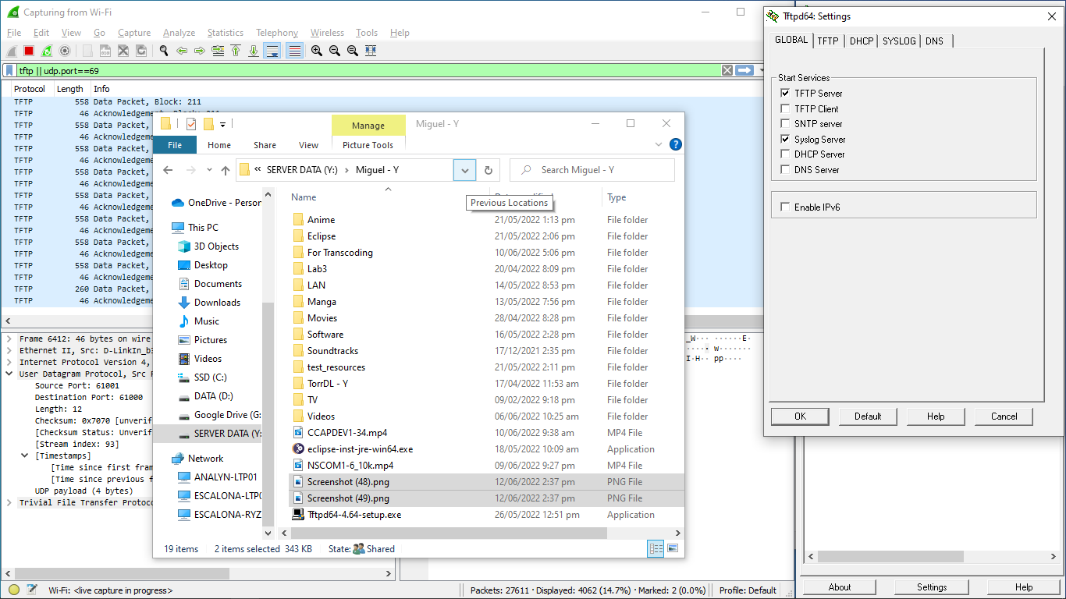
3. Select OK and close the application and re-open again as Administrator.
4. Go to settings again and click the TFTP tab and enter ‘61001:61001’ on the “local port pool”  
   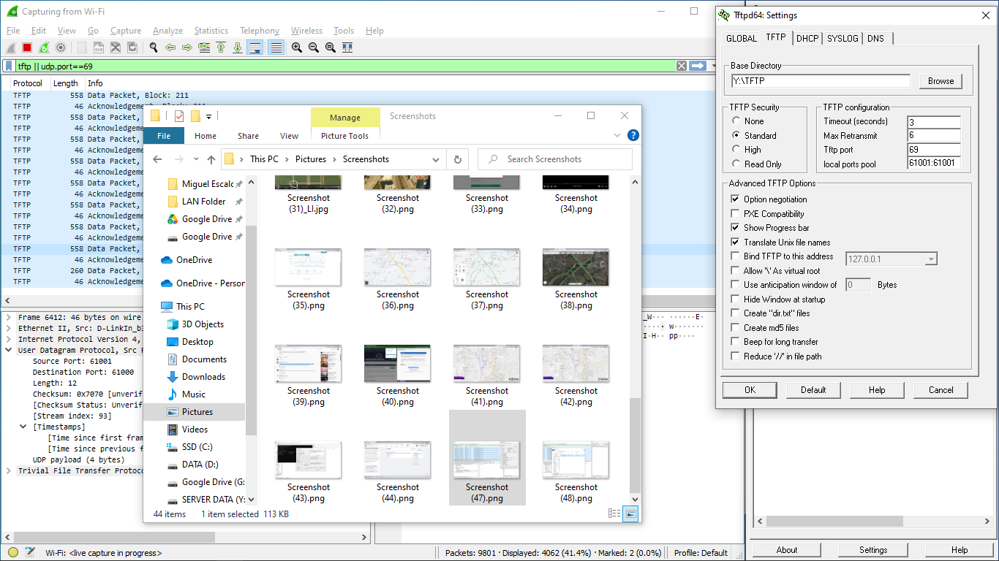
5. Close the TFTPd64 application and restart again as administrator to validate that the settings have been saved.
6. Check if the settings are as expected:
   1. TFTP server is enabled.
   2. TFTP local ports pool is set to: “61001:61001”
7. If the settings are expected, then you are set to use the TFTP Client.